|  |  |
| --- | --- |
| **Use Case Name** | Show shuttle bus schedule |
| **Goal in context:** | User get current shuttle bus schedule |
| **Trigger** | User clicks the ‘bus schedule’ button |
| **Precondition** | Run HYUmini application |
| **Basic Path** | 1. Student want to check bus schedule, so he or she click the ‘bus schedule’ button in HYUmini application. 2. Application shows two tabs in ‘bus schedule’.   -Shuttle bus tab(displayed by default)  -Commute bus tab   1. ‘Shuttle bus tab’ shows shuttle bus schedule. Using current time, application calculates whether it’s during semester, session or break and decide which schedule to display. 2. Shuttle bus schedule is provided in GUI format. Bus on operating is showed with tracking the current location of the bus. 3. User can check whole shuttle bus schedule by clicking ‘Entire shuttle schedule’ |
| **Alternative Paths** | 3a. If current time is not operation time, the page shows the earliest shuttle bus schedule. |
| **Post Condition** | Shuttle bus schedule is provided in visualized format |

Brief description : user can check shuttle/commute bus schedule

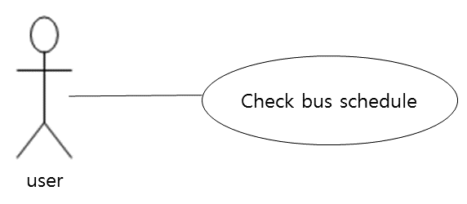

|  |  |
| --- | --- |
| **Use Case Name** | Show entire shuttle bus schedule |
| **Goal in context:** | To provide entire shuttle bus schedule |
| **Trigger** | User clicks the ‘Entire shuttle schedule’ button |
| **Precondition** | User checked shuttle bus schedule |
| **Basic Path** | 1. User clicks ‘Entire shuttle schedule’ button to check entire shuttle bus schedule. 2. Entire shuttle schedule is displayed with three tabs, ‘Semester’, ‘Session’, ‘Break’ 3. ‘Semester’ tab is displayed in default |
| **Alternative Paths** |  |
| **Post Condition** | Entire shuttle bus schedule is provided in visualized format |

|  |  |
| --- | --- |
| **Use Case Name** | Show commute bus schedule |
| **Goal in context:** | User get commute bus schedule |
| **Trigger** | User clicks the ‘commute bus schedule’ tab |
| **Precondition** | User checked shuttle bus schedule |
| **Basic Path** | 1. User clicks commute bus schedule tab to check commute bus schedule. 2. In commute bus schedule tab, user can select which route to be displayed among 9 routes. 3. Application displays selected route in detail with GUI form. |
| **Alternative Paths** |  |
| **Post Condition** | Commute bus schedule is provided in visualized format |